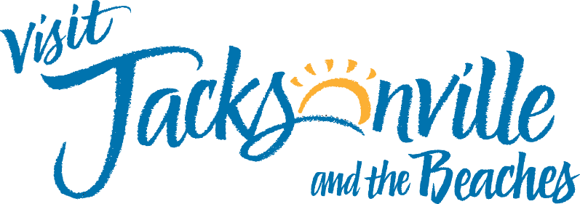
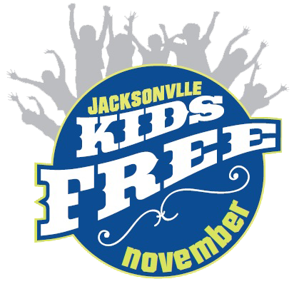

Suggested Social Media Copy for Participating Attractions
Here are some suggested captions that you can post on your social media accounts to promote Kids Free November, along with the graphics/videos provided in the kit and your own photos:
You can customize your caption to include your own deal and also your individual attraction landing page.
- It’s time to plan a fall trip with the kids to Jacksonville! Come visit 17 of Jacksonville’s top attractions at a discounted price throughout the month of November, including ours! Check out the list of Kids Free November participating attractions here.
- We are a proud participant of Visit Jacksonville’s Kids Free November program. That means that for this whole month, you and your kids can enjoy 17 of Jacksonville’s top attractions at a discounted price. At [insert your attraction name] our deal is [insert deal details]. See the full list of Kids Free November participating attractions here.
- Participate in the Kids Free November Challenge through the Visit Jax app! Come visit us and scan our QR code to complete the objective. Once you visit 10 participating attractions, you will be able to claim your prize! Find more details here.

