Thank you for participating in Kids Free November! We are excited to have 17 wonderful attractions involved this year.
New this year is the Kids Free November Challenge. Below you will find instructions on Kids Free November and the new QR code challenge on our Visit Jax App!

Information about the Kids Free November 2023 Challenge:
- Valid November 1-30, 2023, just like the Kids Free November deals.
- Participants need to scan 10 QR codes from different attractions to receive their prize.
- Prizes must be claimed by February 1, 2024. Participants can choose to have the prizes mailed to them or picked up from Visit Jacksonville’s Downtown Visitor Center located at 100 N. Laura St. If they wish to pick up their prize in person, they will need to show the front-desk person at the Visitor Center the “Challenge Submitted” email they will receive upon completion of the challenge and form submission.
- Each challenge submission guarantees the submitter ONE prize pack.
How to participate in the challenge (please refer to this if customers have any questions):
- Participants (in this case will most likely be the parent or guardian) will need to either have the Visit Jax App already or download it by going to their App Store and searching for “Visit Jacksonville”. The icon looks like this:
- Once in the app, participants must search for “Kids Free November 2023 Challenge” to get started.
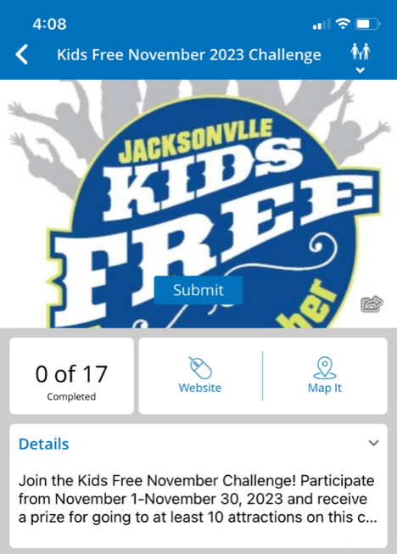
- They will click on whichever attraction they are visiting at that time.
- They will then need to click “Scan QR Code” and hover their phone camera over your attraction-specific QR code for that objective to be completed. It is very important that participants open the app challenge FIRST and then scan the QR code. If they open their camera app and scan the QR code it will not do anything. They must be in the challenge on the app.
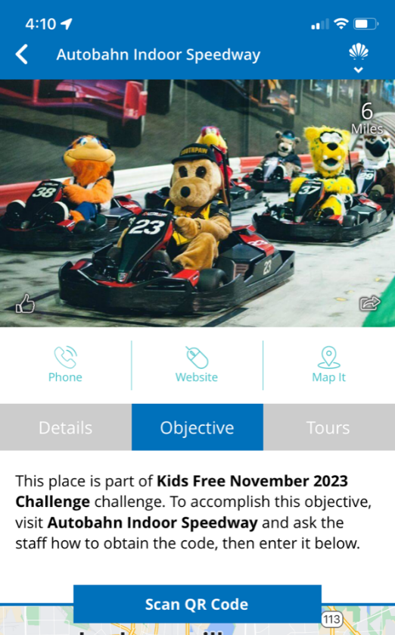
- Once 10 QR codes are scanned, they will automatically be able to fill out the challenge submission form.
- Once the form is completed, they will receive a confirmation email that their challenge has been submitted. That email confirmation, “Challenge Submitted”, is what they will need to bring to the Visitor Center if they opted to pick up their prize in person.

