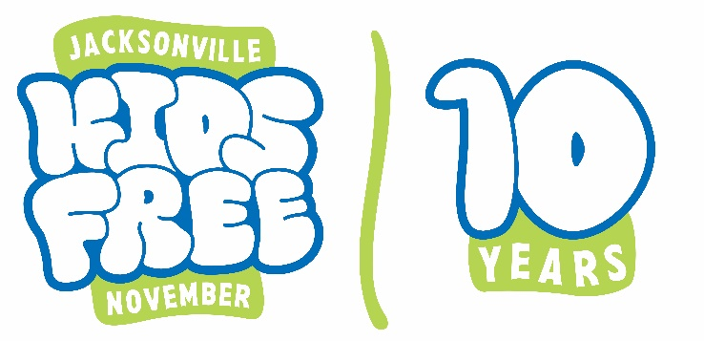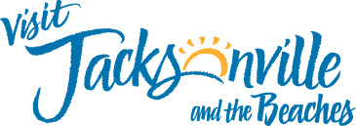

Thank you for participating in Kids Free November! We are excited to have 17 wonderful attractions involved this year.
Below you will find instructions on the Kids Free November challenge on our Visit Jax App!
Please note: Participants do not have to partake in the challenge in order to receive the Kids Free November deals at each location. This is just an extra fun way to increase interaction and engagement with the community. If you ever have any questions, feel free to reach out to lhickox@visitjacksonville.com.

Information about the Kids Free November 2024 Challenge:
- Valid November 1-30, 2024, just like the Kids Free November deals.
- Participants need to “check-in” on the Visit Jax app under your location. This is all location-based so there is no code required.
- Prizes must be claimed by February 1, 2025. Participants can choose to have the prizes mailed to them or picked up from Visit Jacksonville’s Downtown Visitor Center located at 100 N. Laura St. If they wish to pick up their prize in person, they will need to show the front-desk person at the Visitor Center the “Challenge Submitted” email they will receive upon completion of the challenge and form submission.
- Each challenge submission guarantees the submitter ONE prize pack.
How to participate in the challenge (please refer to this if customers have any questions):
- Participants (in this case will most likely be the parent or guardian) will need to either have the Visit Jax App already or download it by going to their App Store and searching for “Visit Jacksonville”. The icon looks like this:
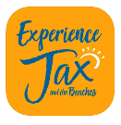
- Once in the app, participants must search for “Kids Free November 2024 Challenge” to get started.
- They will click on whichever attraction they are visiting at that time.
- They will then need to click “Check-in”. This will complete the objective for your location. It is as simple as that! No code is required since it is all location-based.
- Once they “check-in” at 4 participating Kids Free November locations, they will automatically be able to fill out the challenge submission form.
- Once the form is completed, they will receive a confirmation email that their challenge has been submitted. That email confirmation, is what they will need to bring to the Visitor Center if they opted to pick up their prize in person.

