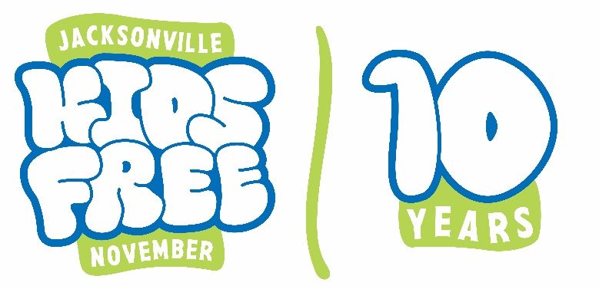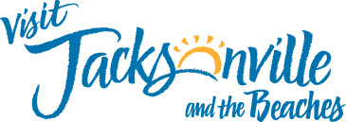

Suggested Social Media Copy for Participating Attractions
Here are some suggested captions that you can post on your social media accounts to promote Kids Free November, along with the graphics/videos provided in the kit and your own photos:
You can customize your caption to include your own deal and also your individual attraction landing page.
- It’s time to plan a fall trip with the kids to Jacksonville! Come visit 17 of Jacksonville’s top attractions at a discounted price throughout the month of November, including ours! Check out the list of Kids Free November participating attractions here.
- We are a proud participant of Visit Jacksonville’s Kids Free November program. That means that for this whole month, you and your kids can enjoy 17 of Jacksonville’s top attractions at a discounted price. At [insert your attraction name] our deal is [insert deal details]. See the full list of Kids Free November participating attractions here.
- Participate in the Kids Free November Challenge through the Visit Jax app! Come visit us and check-in to complete the objective. Once you visit 4 participating attractions, you will be able to claim your prize! Find more details here.

